Views :

* Does not contain any data.
* Only for reading data from 2 or more tables. So to read from 2 or more tables we need atleast a common column.
* Data is clubbed from these tables using joins.
* 2 types of Joins
  + Inner ( o/p- only matching rows from both the tables)
  + Outer Join or Left Outer Join( o/p- all records from table1 or LHS table and unmatching rows from other table or RHS is displayed).
* 4 Types of Views:
  + Database (done using INNER JOIN)
    - Contains only matching records
    - Can contain entire table as well
      * Z149456_FRKTAB—EMPNO
      * Z149456_FRSTTAB—EMPNO
    - select empno, name, employyyee1, deptno

from emp, dept [view fields]

where emp.empno=dept. empno [table/join condition]]

and emp.name=’ALPHY’. [selection]

Z149DB – data base view.ab condition]

* + Projection—1 single table – editing possible – will edit records from the base table.
  + Help – created on 1 or more tables for “search Helps”. It uses Outer join condition. Can only Read data. Cannot execute them directly – designed specifically for Search Helps.
    - Search Helps: F4- i.e displays all the possible values for a field in the form of a list.
    - 3 types:
      * Elementary : in selective method u put either table name or view name.

Lpos is for selection screen and output and Spos is for restriction screen(after u click on restriction icon shown in scrn shot below). When export is unchecked it leads to data not shown in the selection screen after selecting from F4.

After creating elementary search help assign it to a field of emp table.

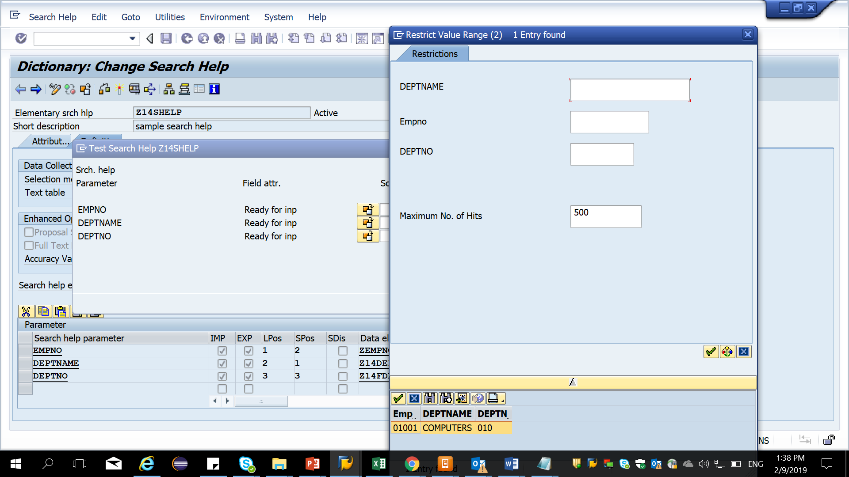

* + - * Collective : u can include other elementary search helps created and search against those search helps. Z14CHELP. Need to do parameter assignment for those elementary search helps – this indicates which parameter from the elementary search help will be shown in the output against the search help parameter.
  + Maintenance view : Cannot be created on standard tables. after creating maintenance view we need to create TMG for it, then only changes can b made thru the view. Direct out put does not come for maintenance view. Need to use SM30. Data changed reflects in the underlying table.